Path Day 2 Class Assignment

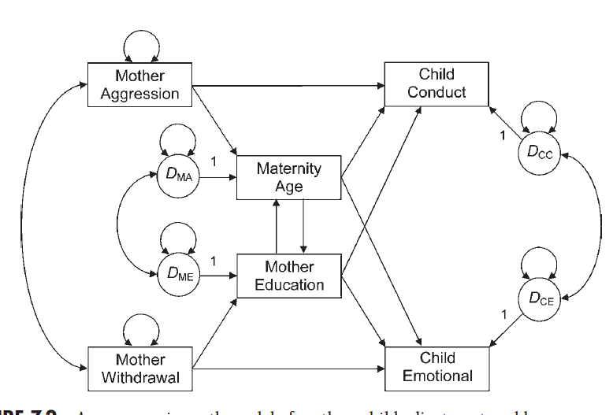

Data:

aggression 1.00

withdrawal .19 1.00

education -.16 -.20 1.00

mat_age -.37 -.06 .36 1.00

emotional -.06 -.05 -.03 -.25 1.00

conduct .13 -.06 -.09 -.28 .41 1.00

N = 200.

Use the above model for model 1.

* Program the model in R.
* Run the fit of the model.
* Include the fit indices in a table (see below).
* Include a picture of the model.

For model 2, remove either the environmental component (withdrawal and aggression) or the genetic component (age, education used as a proxy for IQ).

* Program the model in R.
* Run the fit of the model.
* Include the fit indices in a table (see below).
* Include a picture of the model.

|  |  |  |
| --- | --- | --- |
| Index | Model 1 | Model 2 |
| Chi-square (df) |  |  |
| RMSEA |  |  |
| SRMR |  |  |
| CFI |  |  |
| TLI |  |  |
| NFI |  |  |
| AIC |  |  |
| ECVI |  |  |

Which model is better?

Interpret the loadings of the better model – what do they seem to imply? Are they significant?